2022

James Caroe

UTc OLP

LO2 LO4

Contents

Overall Review of LO3 2

Positives 2

Negatives 2

Improvements 2

Brief 2

Wireframe 2

Mood-board 3

Fonts 3

Colour Scheme 3

Assets 3

Survey 3

Colour Scheme 3

Fonts 4

Wireframe 4

Age Range 5

AR Feedback 5

User’s Confidence 6

Summary 6

# Overall Review of LO3

I have made a design document to plan for the creation of an AR application for Kelham Island Museum. It will guide people around the museum and give people a more in depth, immersive experience. I will be reviewing how my design document was.

## Positives

* I have a good GANTT chart, which is easy to display and to read. I found it very easy to make and it went very well
* I made a good wireframe that looks very clean and easy to use if it was created into a product
* My mood-board gives a very good feel of what I want my application to look like.

## Negatives

* Choosing my fonts was more challenging, and I’m not sure that I chose the best font.
* Creating a colour scheme wasn’t very easy, and it didn’t turn out very well.

## Improvements

* I could make a better colour scheme to improve the whole feel of the application
* I could improve my sitemap which isn’t very clear. This would help people to understand my application

## Brief

I think my design document matches the brief very well, it abides by the brief to make a product that can be used in Kelham Island Museum. It will help people get an upgraded experience at the museum by getting more information and getting guided from their own device.

# Wireframe

I made a good wireframe which gave a clear understanding of what my product would look like. I could’ve made it so that the wireframe looked like a mobile device rather than a rectangle. Overall, the wireframe turned out well, and there ended up not being many things that I could improve. I could’ve given more description about the fonts used on the wireframe though.

# Mood-board

My mood-board gave a good feeling how I would like my application to look like. I managed to choose a good selection of images for my mood-board and filled all the spaces. I could’ve arranged the images a bit better to give a less cluttered feel to it.

# Fonts

I have chosen some good fonts for my product. The sans-serif font that I will use for the main body of my product is very clear and won’t be very hard to read and understand for all users. My display font that I will use for my titles in my product isn’t extremely easy to read, but it looks very nice. I could choose a better display font so that all users can read and understand my product titles.

# Colour Scheme

I have chosen a colour scheme that reflects on Kelham Island Museum’s themes. The green and dark blue reflects the common colours on machinery, and the other colours also reflect this. I would hope that this allows the user to get more immersed into the experience. I could sample some colours from the museum if I wanted to get a more accurate colour scheme.

# Assets

I have got a list of things that I will need for my product. I have got quite a selection of assets and have identified most of the things that I will need to use. To improve I will need to find every asset that I will need and list them.

# Survey

## Colour Scheme

Most people said that they prefer a different colour scheme to the one that I was going to use. I will take this into consideration and do some more research on the best colour scheme. I may change my colour scheme to the most preferred colour scheme

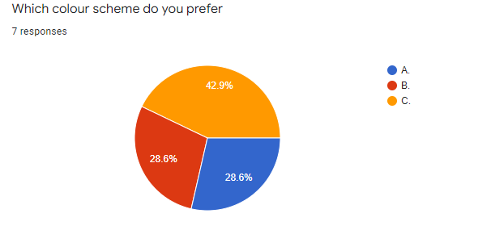

## Fonts

Most people preferred the font that I have chosen for my product, I think that it is the best font overall, and the consensus seemed to fit with my thoughts. I won’t change the font because 85.7% of people like the font that I chose, and this suggests that it is a very good selection.

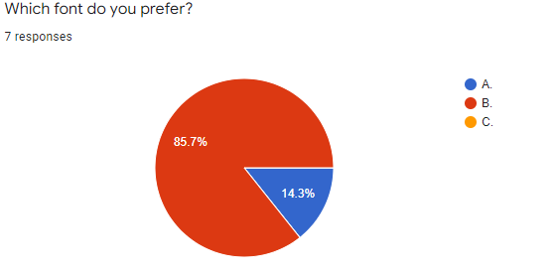

## Wireframe

Most people didn’t like the wireframe proposal that I made, and so I am going to change this. 85.7% is a very large percentage that don’t like my idea, so I will have to redesign my wireframe. I will make my wireframe more like the other example that I gave as an option.

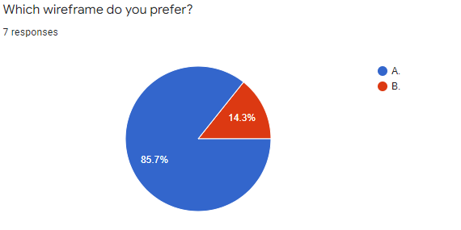

## Age Range

100% of people said that an AR app would be best suited for 14-20 year-old people. This fits with my own research that I have conducted. Younger people would not be interested, and older people may not know how to use the application. I will target my app towards that age range.

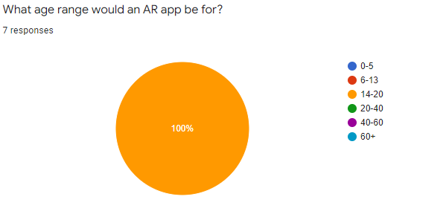

## AR Feedback

I got some feedback what people would like to see in an AR application, I will take this into consideration while making my application. There are some very good suggestions, and I will include some of the ideas into my product.

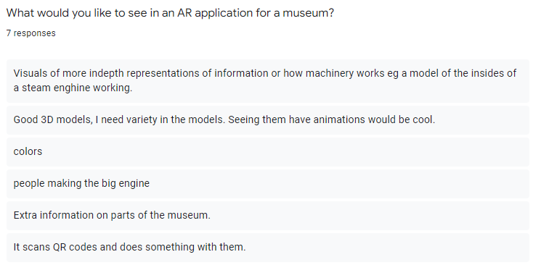

## User’s Confidence

100% of people said that they would know how to use an AR application, this may be because most people that answered the survey are young people, and so are better at tech. I will make sure that anyone that isn’t so confident can use the application easily.

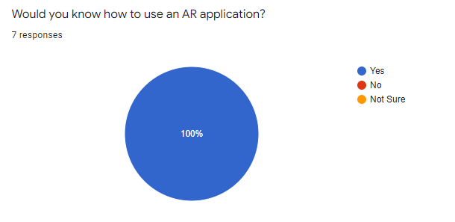

# Summary

Overall, I think that my design document turned out very well. I chose some good fonts I will choose a better display font so that all users can read and understand my product titles. I have created a good colour scheme. I will sample some colours from the museum to get a more accurate colour scheme. I also got a good list of assets that I will need improve, I will find every asset that I will need and list them. I will improve my wireframe, I will give more description about the fonts used, and will create a better, clearer design. I will focus my product to target 14–20-year-olds, this will hopefully attract more people towards my product. I will make sure that everyone that wants to use my product will be capable, and be able to use it without too much struggle.